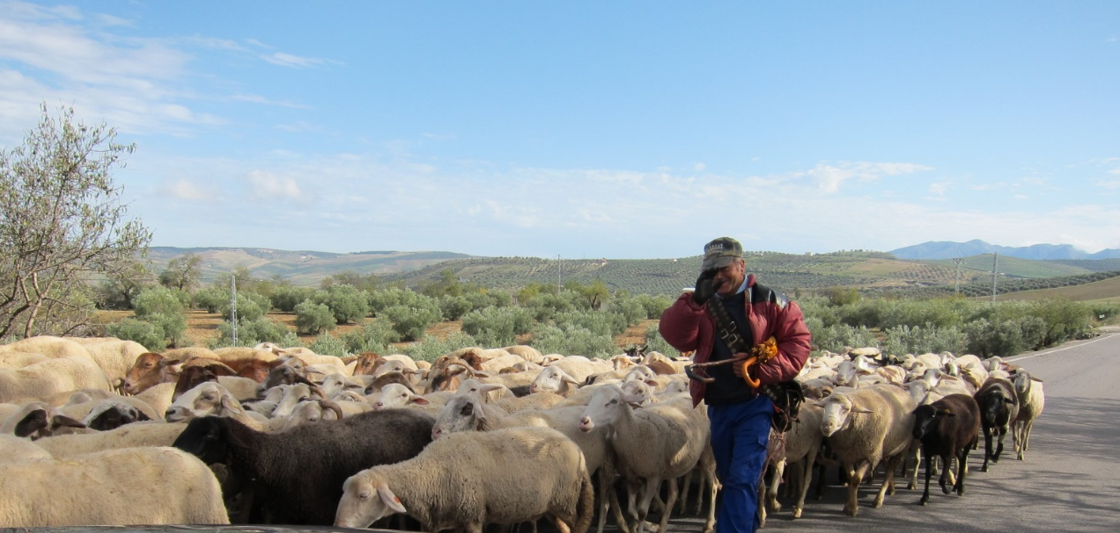

Roadbook from La Canada, Marbella

to Estepona
From La Canada at the roundabout take to the right in direction Ojen A-355
After 14.8 km take Exit to Monda, to the left under the bridge, then to the right
In Monda take to the left
Follow A-7100 in direction Gauro
Pass Gauro and continue the other side A-7100
After 29,7 km you come to a T-crossing, take to the left in direction Tolox, Alozaina and Yunquera A-366
After about 38 km you come to Alozaina – continue A-366 in direction Yunquera
After 45,3 km you arrive to Yunquera
In Yunquera take to the right Carretera al Burgo. Follow A-366 in direction El Burgo (will change name to Calle de Malaga)
Arriving to El Burgo, after passing over Rio Burgo keep to the left (A-366)
Take a break in El Burgo.
Continue A-366 in direction Ronda
When arriving to Ronda in the roundabout take the San Pedro exit (3rd exit?)
From Ronda we drive about 42 km down to San Pedro de Alcantara
Take a break. There are several parking places with wonderful views.
Be aware of the Speed Cameras – several!
When you arrive to San Pedro, after passing the exit to Los Arqueros, in the roundabout before you go under the motorway AP-7, take to the right downhill
Continue straight ahead until you reach the Benahavis road – go straight ahead uphill
Follow the road straight ahead all the way down to the Carretera de Cadiz A-7
Take to the right in direction Estepona
HomeCare Estepona www.homecareestepona.com Telephone +34 952 880 630 info@homecareestepona.com

